Local Development Worker Newsletter Summer 2024

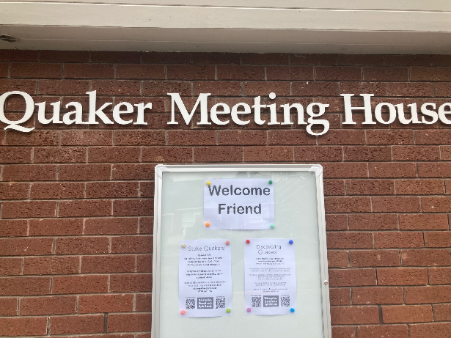
Welcome to the Summer newsletter. It’s almost the end of May, and the Government have just announced a General Election. This gives us a key opportunity to speak out on Quaker values. QPSW have produced a wide range of resources to help Friends and Quaker Meetings engage with the election including a guide to hustings, individual issue guides and children’s resources. Find the whole set at www.quaker.org.uk/vote.
It’s been lovely to see many of you at the Peer Support Zoom sessions. They are being run jointly between myself and Craig Barnett who is the Local Development Worker in Yorkshire. You can find the dates and booking links of the next ones at the end of this newsletter.
For the last two Saturdays I’ve enjoyed spending time with Friends at Area Meetings, with the common theme being a shared lunch eaten in the garden of a beautiful old Meeting House. Today it’s been raining all day, so I’m hoping the sun comes out again in time for a weekend camping trip.
In Friendship,
Hilary Topp

Welcoming Newcomers
In each newsletter I’m going to offer a few ideas around a question that has come up at several Local or Area Meetings. This month’s question is ‘How can we support enquirers/newcomers?’
The following is adapted from https://quakersinyorkshire.org.uk/welcoming-newcomers/

Some ideas for welcoming newcomers to your Meeting
- Have a sign or A-frame noticeboard outside with the times of your meetings, contact details, and an up to date poster (available here).
- Make sure your meeting details are correct on the Quaker website. If anything needs changing, send details to: updates@quaker.org.uk.
- Encourage your doorkeepers to practise a short welcome for anyone who is at a Meeting for the first time, e.g. “It’s lovely to see you. We will meet for an hour sitting quietly together, and anyone who is moved to may speak to us during this time. Please sit anywhere, and make yourself comfortable. We have some information about Quaker worship, and do come and talk to one of us over coffee afterwards if you’d like to.”
- Have some leaflets available, but be ready to explain things yourself as well. Explain what is happening, and why, to everyone as a matter of course.
- Discuss with your meeting how to welcome families with children, even if you don’t have a regular children’s meeting.
- When giving notices, introduce yourself and invite anyone who is new or visiting to introduce themselves if they would like to (without pressure). In a small meeting, you could ask everyone to introduce themselves. Point out who newcomers can approach with questions.
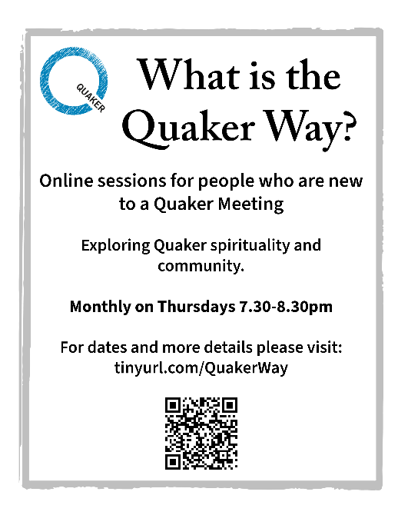
- An afterword or sharing of ‘joys and sorrows’ after Meeting can be a good way for newcomers to participate.
- Talk to newcomers after Meeting. Show an interest in their lives and experiences. Remember that everyone has a unique life history – not all young people are students for example.
- Ask newcomers if they would like to be added to the Meeting WhatsApp group if you have one, or the meeting email list.
- Offer everyone a copy of Advices & Queries.
- Arrange regular shared meals or other social events and invite newcomers.
- Invite newcomers to take part in the What is the Quaker Way? online sessions – see details here.
- Offer a regular session for spiritual learning and exploration, either as a Local or Area Meeting. This could be sharing of personal journeys, exploring Quaker faith & practice or another Quaker resource such as Being Quaker, doing Quaker. Some meetings have a short discussion on a particular topic straight after Meeting for Worship once a month.

When people have been attending for some time:
- Talk to them about how Quakers make decisions in community and invite them to take part in a Business Meeting.
- Ask attenders if they’d like to go to an online or in-person Woodbrooke course, or a ‘Curious about Quakers’ weekend at Rookhow (www.rookhow.org.uk) and explain that the meeting/Area Meeting can offer a bursary for this.
- Ask if they would like to be more involved in the Meeting, and what kinds of things they enjoy or could help out with. Check if they would like to be part of any Pastoral Care arrangements that you have in place.
- Explain how membership works and encourage them to think about whether it is right for them.

News from around the LDW ‘patch’
George Fox 400
2024 marks the 400th anniversary of the birth of George Fox, one of the founders of Quakerism. Many of you are busy planning events for ‘George Fox 400’. If you would like any support, ideas or resources please get in touch with Ellie McCarthy on Georgefox400@quaker.org.uk. Ellie can send you resources, including a template press release, and help you think through your plans.
A few events that I’ve heard about so far include Stafford Meeting holding coffee mornings on several Saturdays over the summer, Hartshill Meeting, which is the closest meeting house to where George Fox was born, hosting a celebration day on the 25 May, and several Local Meetings that are planning to take part in the Heritage Open Days in September and tie this in with the George Fox anniversary.
Other things I’ve heard about, which may or may not feature George Fox, are Area Meeting all-age picnics, spiritual journalling workshops, a new worshipping group being established in a town that doesn’t have a Quaker Meeting, meetings thinking about their pastoral care arrangements and how they can best meet everyone’s needs, Area Meeting days thinking about priorities for the future, Local Meetings coming up with creative ways of sharing tasks and roles amongst a wider group of Friends, book groups, Youth Group sleepovers, Teenage General Meeting events, plans for a Quaker Families weekend, an ‘ageing Friends’ discussion group, community breakfasts, craft drop-ins, Area Meetings thinking about their communications, outreach and social media and lots more!
If you’d like to know more, or need any help with anything similar, or totally different, please get in touch. If I can’t help, I can point you towards someone who can. hilaryt@quaker.org.uk

Upcoming events
A few things that you might be interested in- sorry this isn’t a complete list of everything that is happening. If there are events you would like me to include in a future newsletter, please send me details before September, or think about also putting them on your own websites and on the ‘Quaker Space’ Facebook page.
1 June Quaker Arts Network Day at the Priory Rooms, Birmingham Quaker Arts Network Day in Birmingham – Quaker Arts Network
Lots of online events listed here including Outreach Network 3 and 10 June, Faith in Action drop-in 12 June, Website and Social Media Support 19 June
A monthly meeting for those working with young people in Quaker settings – second Wednesday of each month 7.30-9.00pm. Register for the next meeting.
A monthly meeting for those involved with Children's Meeting and All Age Worship – third Thursday of the month on zoom, 7.30pm–9pm. Register for the next meeting.
Zoom support sessions – click the links to register, and please share with Friends in your meeting
Local Meeting Clerks
Monday 23rd September 7.30pm

Trustees
Thursday 10th October 7.30pm

Pastoral Care
Monday 14th October 7.30pm

Treasurers
Thursday 6th June 7.30pm
Thursday 7th November 7.30pm

Nominations
Thursday 13th June 7.30pm
Wednesday 13th November 7.30pm

Eldership
Thursday 20th June 7.30pm
Monday 18th November 7.30pm

