Lord Mayor of Coventry Committee
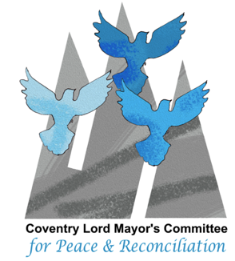
for Peace and Reconciliation

Coventry Hiroshima Remembrance 2022
Taiko Drumming Workshop
by James Barrow (Taikowest)
10.30am to 12 midday Saturday 6th August 2022
at Coventry Cathedral

One 90 minute workshops before Hiroshima Day 2022 Saturday 6th August 2022- We have 15 places. Suitable for primary and secondary school students.
A performance by some students for 10 minutes will happen at between 1pm and 2pm as part of Hiroshima Day. To attend is Free
Coventry Hiroshima Remembrance is between 2pm and 3pm.

If you are interested please contact David Fish Coventry Lord Mayor’s Peace Committee davidfishcf@msn.com
Please apply as soon as you can – we need to gauge early interest and set up a reserve list.
This event is arranged by Coventry Lord Mayor’s Peace Committee and Coventry Cathedral. This event is happening by the kind permission of Coventry Cathedral

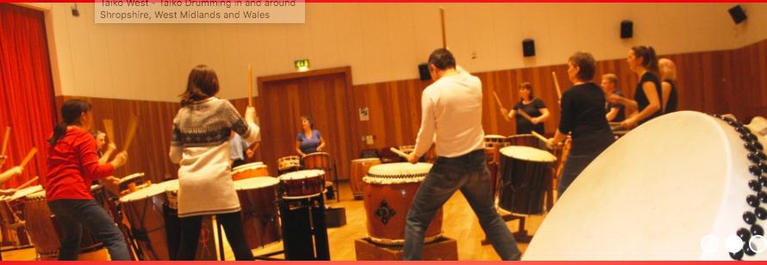
David Fish 26th June 2022
Davidfishcf@msn.com

